AI WEATHER WISE API PROJECT DEMONSTRATION
API TESTING
Register API:
The user registration functionality was demonstrated using a POST request to the registration API. The user provides the required details such as name, email and password. The API processes the request and creates a new user account.
API Method: POST
Endpoint: /api/auth/register
Demonstration:
- Enter the user's name, email and password.
- Send the POST request.
- Verify the successful registration response.
- The registered user can then use the login functionality.

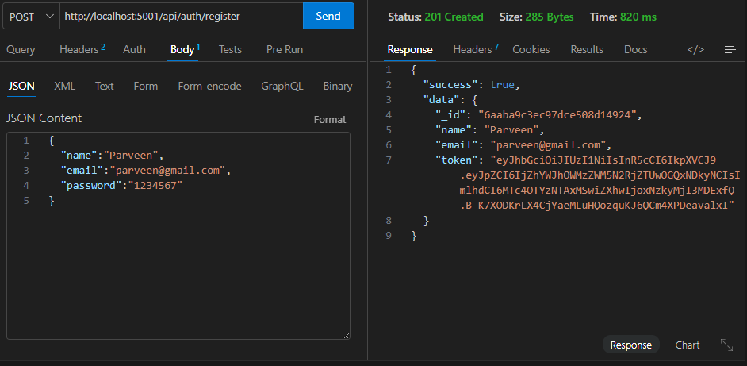

Login API:
The login functionality was demonstrated using a POST request. The registered user's email and password are submitted to the login API for authentication.
API Method: POST
Endpoint: /api/auth/login
Demonstration:
- Enter the registered email and password.
- Send the POST request.
- Verify the authentication response.
- Successfully authenticated users can access the application services.

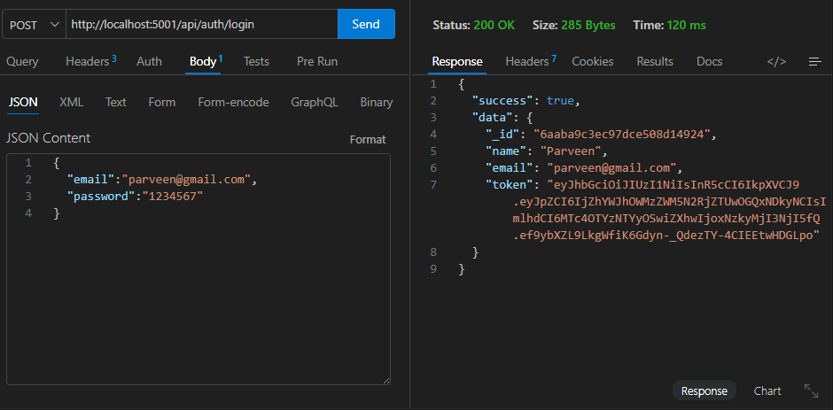

Weather API:
The weather retrieval functionality was demonstrated by requesting weather information for the selected location.
API Method: GET
Endpoint: /api/weather/chennai
Demonstration:
- Send the weather request.
- Retrieve the weather data from the weather service.
- Display the available weather information in the application.

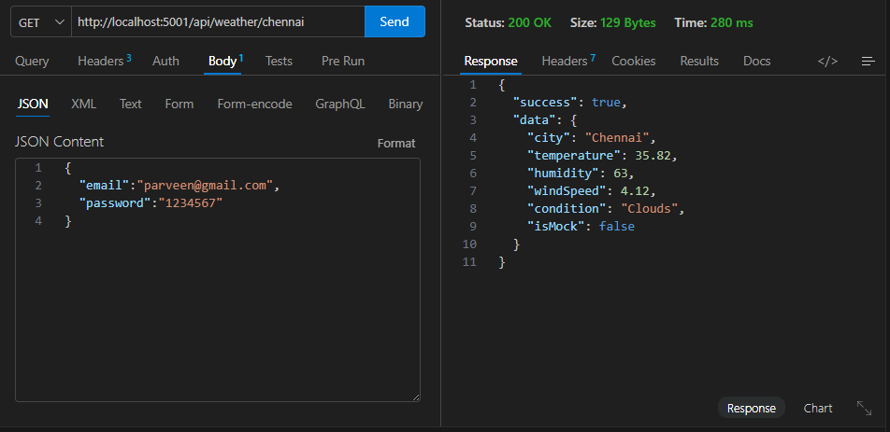
Weather Summary API:
The AI weather summary functionality was demonstrated by sending the available weather data to the AI service. The system processes the weather information and generates an easy-to-understand summary for the user.
API Method: POST
Endpoint: /api/ai/weather-summary
Demonstration:
- Send the available weather data to the AI summary API.
- Process the weather information.
- Generate an AI-based weather summary.
- Display the summary to the user.

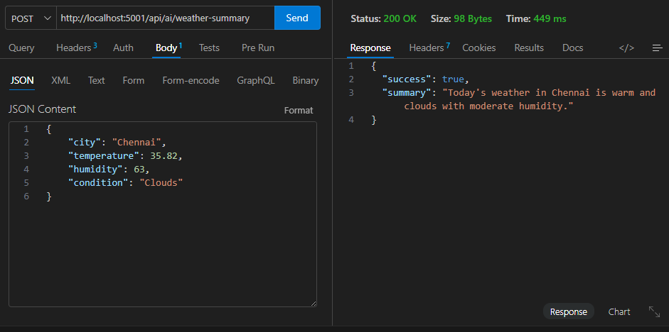

Weather Recommendation API:
The recommendation functionality provides useful suggestions based on the available weather conditions. The weather data is processed by the AI service to generate suitable recommendations.
API Method: POST
Endpoint: /api/ai/weather-recommendation
Demonstration:
- Send the weather information to the recommendation API.
- Process the input using the AI service.
- Generate weather-based recommendations.
- Display the recommendations in the application.

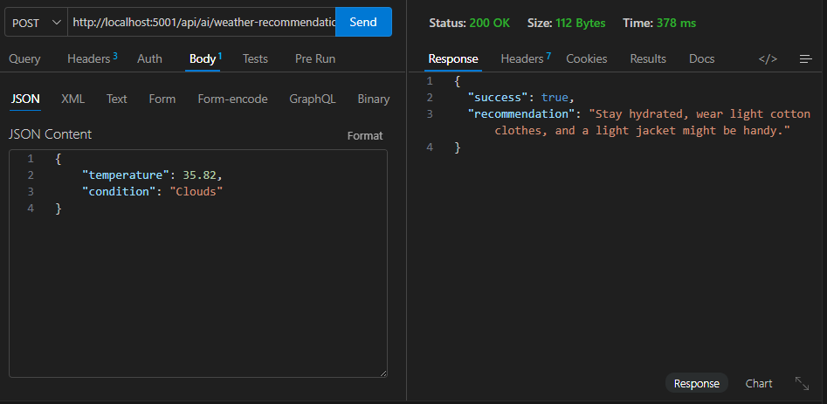

Demo Video Link
https://drive.google.com/file/d/1hWnabZk4pMJwP-HqOlX-m5jqCCpD5T-1/view?usp=drivesdk

